**From:** Phoen, Eugene   
**Sent:** Monday, 05 February, 2018 10:38 AM  
**To:** Chan, Pei-Fong  
**Cc:** Lee, Kar Mei  
**Subject:** Add SKU value to inv snapshot report

Hi Pei Fong,

Can you please pull the ‘Price Unit’ and ‘Price (EUR)’ from SKU master, and add them to the Daily Inventory Snapshot Detail? Ideally after the SKU column –

Thank you!

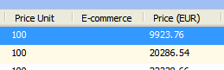

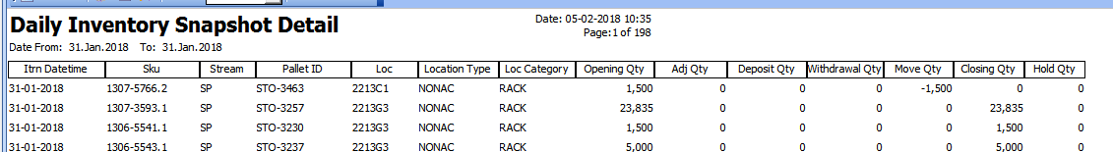

Best Regards,

Eugene Phoen

Assistant Manager

Contract Logistics/SCM, Operations

Schenker Singapore (Pte) Ltd

51 ALPS Avenue Singapore 498783

Office: +65 6549 5813, Mobile: +65 9101 3035

2018.02.06

Added:

